# Training Day

This is a campaign for four heroes. One of them must be a Cogsmith, the others are up to you but do not include a Gryph-Hound.

You can hand the following introduction to players to read on their own, or modify it to narrate it on the day. Then proceed to Warehouse 7.

## Introduction

It was supposed to be a simple job. The damn wizard sounded so convincing. “What, money? That’s easy, my friend! Just go to Hammerall, and tell local coppers that you want to serve in the Permanently Temporary Guard for a day or two. It’s the division that takes care of the simple stuff, like delivering packages, patrolling dead zones and so on. It’s such a boring and soulless job, recruits leave so quickly that they just enroll random adventurers or anyone who asks. Get in, get bored for a few days, and ka-ching! The daily pay is 5 gold. So much easier than cleaning a random dungeon from giant mice, just to find all treasure chest have been looted a long time ago.” *If only*.

The enrollment process was a formality, as the dwarf said. The scribe threw towards me a piece of paper with all details pre-filled, and just gruntled “namesurnameandsignature” without taking his eyes off the miniature dollhouse he was skillfully putting together. After I signed, he looked at the form, stamped it with a huge red sigil, and threw it into a pigeonhole. A very cramped pigeonhole.

“Thepayis5goldpiecesperdayassumingyouhaveservedforanentireday.  
Heresyourdaytoken,bringittoprecinct23tobeassignedatask.  
Goodluckandclosethedoor”. And again he turned to the dollhouse.

So there I was: Precinct 23, also known as “the craphose” – where boring tasks get assigned to out-of-luck mercenaries, adventurers and temporarily-embarrassed heroes of mankind. A tattered banner, marking the entrance, indicated the start of a short queue. The bored bunch was a pretty weird group, with only one thing in common: dented armours, rusty shields, stained capes… these people had seen better times.

By the time I made it to the assignment bar, I had befriended a few of them. The clerk noticed our lively chat, eyebrow raised, and then looked at me.

“Hey chief, you’re a popular guy, uh? I have an assignment here ready for a crew – get down to Evidence and reorder Warehouse 7. What do you say?”  
“You sure you need a whole crew for that?”  
“Ha, you haven’t seen the place. There is enough crap for *twenty* crews, but *somebody* gotta start. Or you can go sweep the stable floor, that’s always a very *popular* option.”  
“Alright, alright, we’ll take it – right guys?” Nobody objected.  
“Great choice, chief.” The room struggled to contain the sarcasm. “Hand me your tokens. The warehouse is the third door to the right, go down five floors then second door on the left. Check in with the dwarf.”  
“Five floors underground, man! Did they carve it out of hell or something?”  
“Can’t be too safe, chief. Lots of bad people used to break in to get rid of incriminating stuff, so we moved it down there five years ago. Not a single problem since. But because it’s so far down, nobody can be arsed to spend time there reordering stuff, and now it’s a mess.”

Stairs were barely lit, as humid as sewers. I almost slipped three times on the damn rocks. I had to bang my fist on the desk to get the guarding dwarf to wake up.   
“Mf, yes, what?”  
“We here to clean up this place.”  
“Oh, they finally sent people.” He looked at us skeptically. “You are… few.”  
“I know, but ‘somebody gotta start’, eh.”  
“Fair enough. I’ll show you around.”

He unlocked the first gate, let us in, and locked it back; then he opened the second gate, and we followed him through. I could barely see my nose in the dark, until he pulled a torch from somewhere where and lit it. And I knew then we were screwed.

The warehouse was made of a series of tunnels and rooms, one more chaotic than the next. Paper everywhere, boxes piled up half-open, broken shelves, rusted chests, glowing vials of Sigmar-knows-what. Swiping stable floors started to look attractive.

“Ok fellas, here’s your kingdom, make it shine. The broom should be somewhere, but to be honest, you’ll first have to figure out what goes where – don’t ask me, do I look like a lawyer? I’ll be at the door if you need anyth-“ and the world went boom. A thunderous bang made us half-deaf. The entire building visibly shook, more boxes falling from the racks.

“What the hell was that?”

We turned just in time to see a mob of fighters crash through the door. They seemed surprised to see us, but almost *happy*. The oldest of the bunch smiled: “Finally some real meat, for Khorne!”. He shouted some nonsense at the group, and they charged towards us.

## Warehouse 7 (start)

Read to players: “As Bloodreavers attack, you realize that the precinct must have been breached. Forget daily pay, you will have to fight your way out!”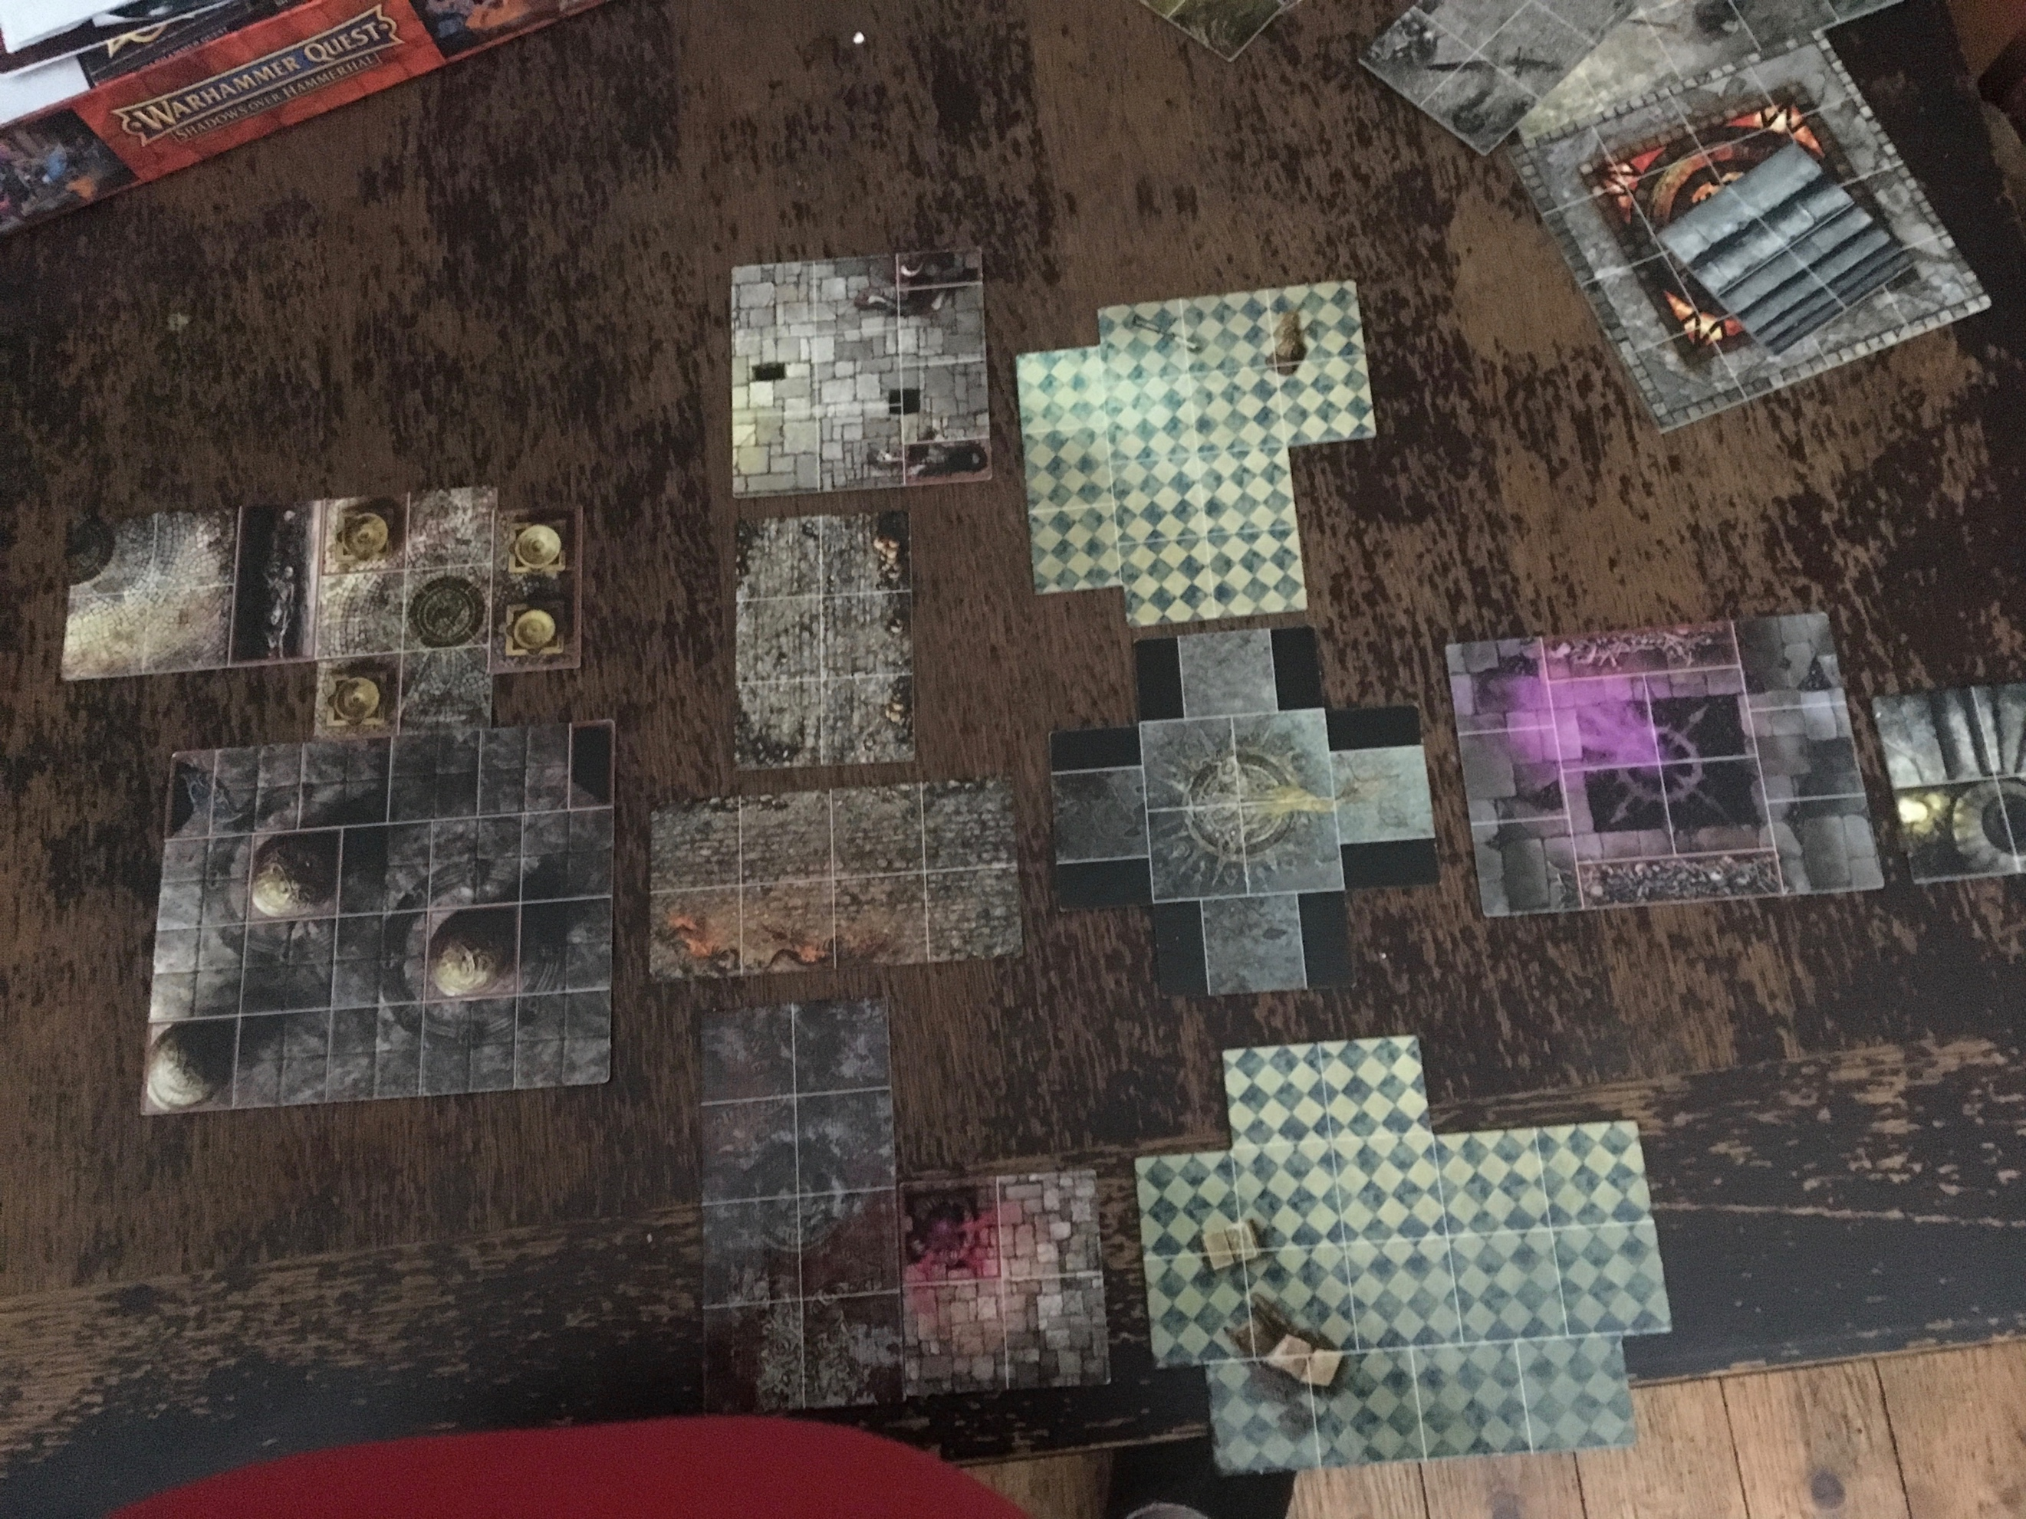

## The Forge

Read to players: “As you ascend, the air around you gets warmer and warmer. ‘Our beautiful forge’ mutters Taruddin, ‘desecrated by these punks. I can’t stand it! Let’s clean it up, what do you say?’ He looks at your tattered weapons with ‘… You really could do with new gear. There is some nifty hardware in there. Just sayin’. He’s right, but that doesn’t make it less irritating. You ponder whether to continue your escape or have a look inside.“  
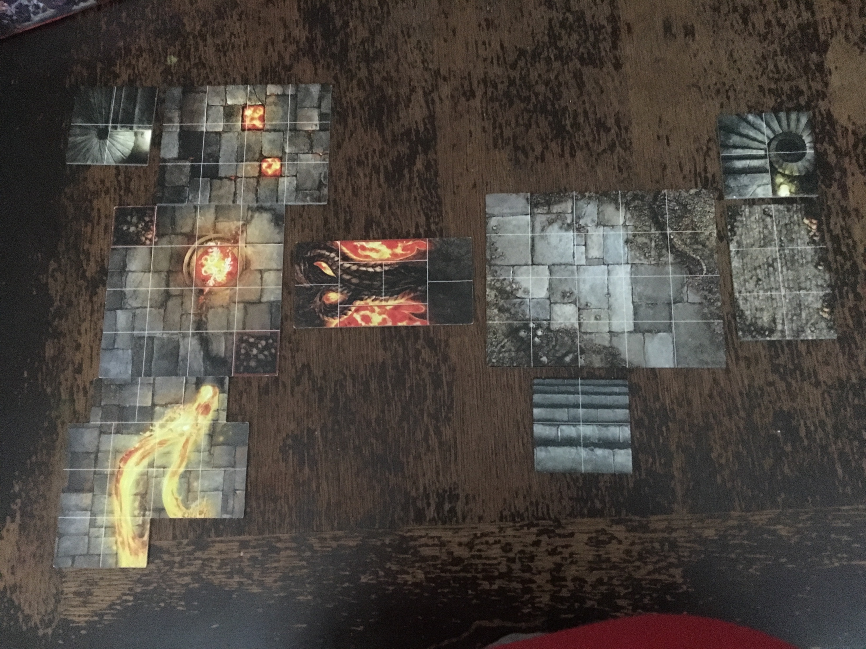

## Pantry and Supplies

Read to players: “The corridor is a mess. Among all the blood and bodies, you can still make out a sign on the wall: PANTRY AND SUPPLIES. This is where the precinct keeps its everyday stuff – food and tools of all sorts. The place has clearly been looted already, but you hear some noise from beyond the door. If you don’t take care of stray groups, you might find them behind you further on.”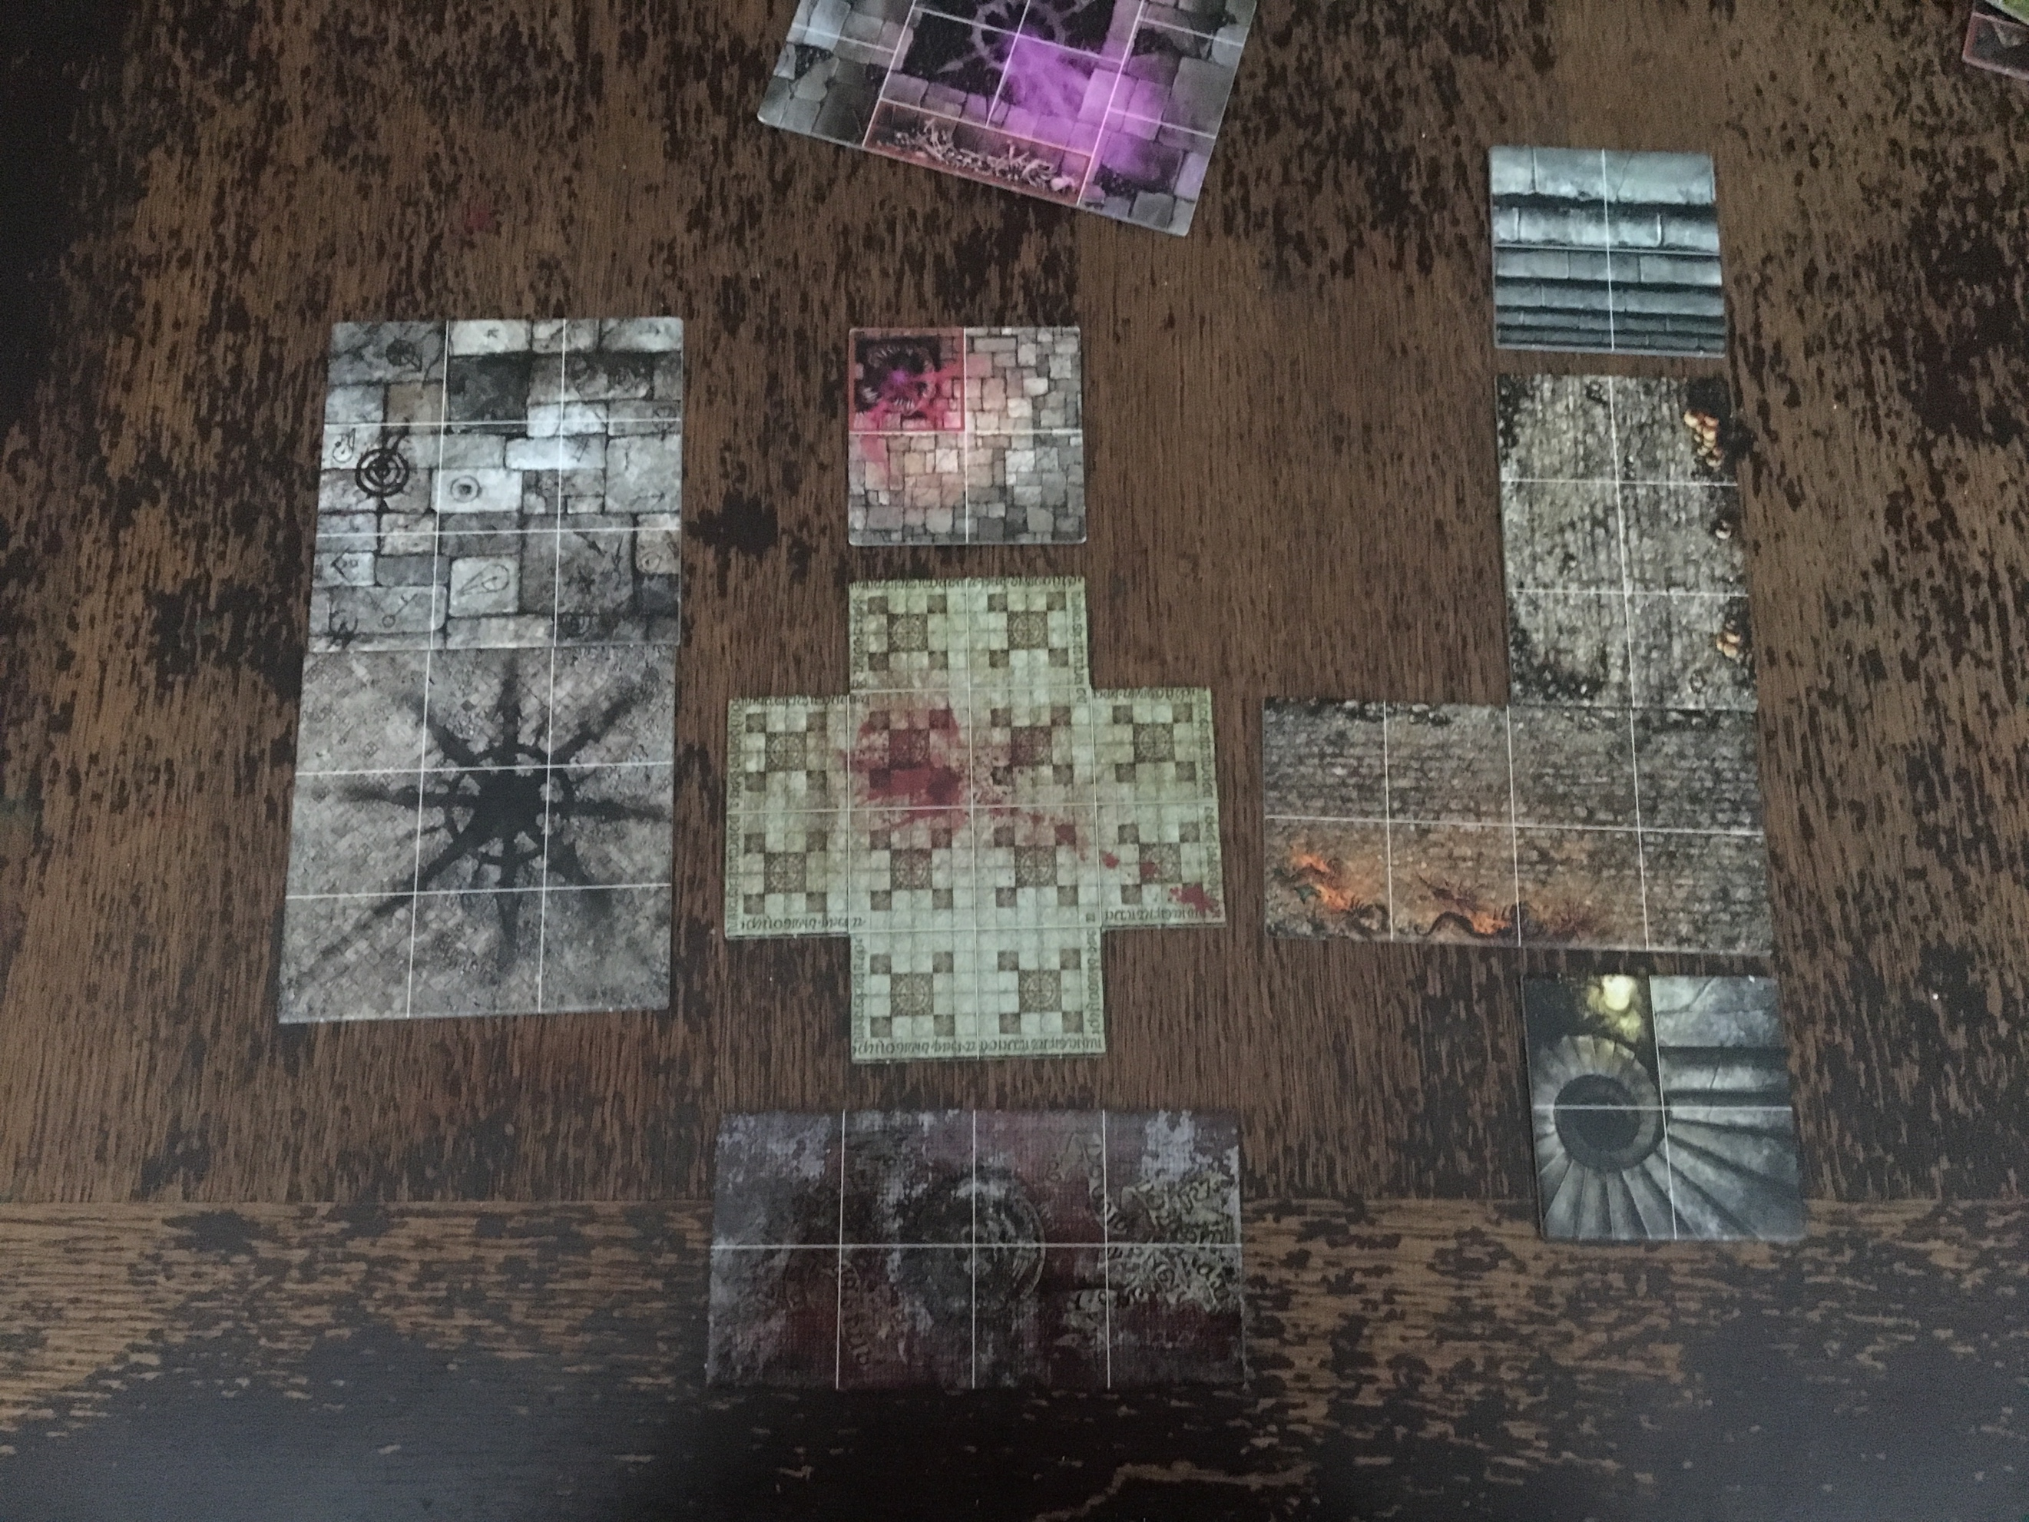

## Dining Hall

“Taruddin is adamant that you should just continue further upstairs. ‘The next floor is just the dining hall and kitchen, mate, and this ain’t time for a sandwich.’ But as you open the corridor door, a distraught dinner lady runs towards you. “Thank Sigmar! You need to help us! The staff are blocked in the kitchen, with monsters everywhere! I was in the closet when they arrived… I heard a ruckus and somebody screaming, so I peeked through the big door… a Liberator was fighting them uglies, such a hero! Hurry up and save him! I’ll get back to my closet, please send help when you get out!”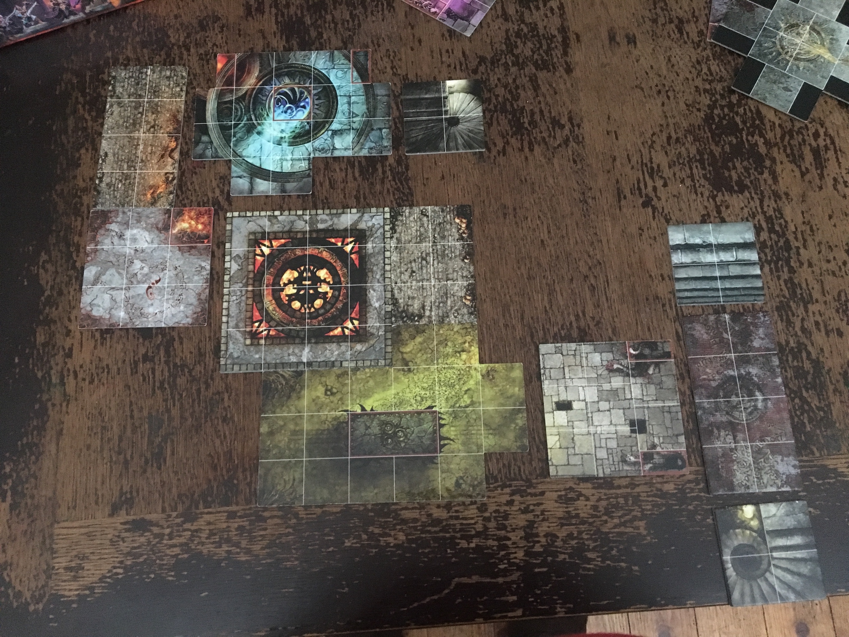

## Precinct Office

(If the party arrives from the northern stairs): “’This is it!’ Taruddin exclaims, “Almost there, boys!”. You enter a small corridor; at the other end, you can see a heavily decorated door. A greenish light emanates from its edges. The nightmare is not over yet.

(If the party arrives from the western stairs): “’This is it!’ Taruddin exclaims, “Almost there, boys!” But his happiness is short-lived. As you carefully open the door, a hellish scene welcomes you. The hall is lit by a sinister greenish light; the air is full of a putrid stench, and sparkles go off randomly mid-air. The nightmare is not over yet.